We have just returned from another great weekend oop north. Having climbed from our bed at 4am on Saturday morning we tried in vain not to make too much noise whilst getting the blue and cream beast on the road to travel up to Wistaston for breakfast
As usual the greasy spoon café, so ably run by Caroline, came up trumps. We then set off for Tatton Park - What a show. The weather disappointed though, as we had come north to escape the southern heat wave but it was a blistering day. Shorts and factor 30 were everywhere.
The Healey stand looked wonderful ( third prize indeed !)
Mad dogs and Healey owners go out in the midday sun - the most enormous BBQ ensued with lots of scrummy food and the odd glass of chilled wine or Pimms was to hand.
Day one over we returned to our hotel, the Curran residence. 5 star but no keys! We did gain entry though… . Who was that? Catwoman?

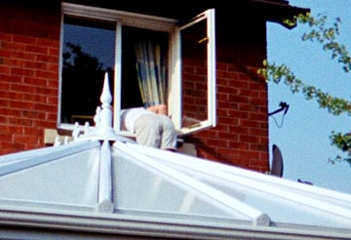

Sunday morning back to Tatton Park where there were lots more cars and many more people than on the previous day and still there was no break in the weather.
Another excellent BBQ lunch, this time cooked by Joe Beaumont. At times the height of the flames could only be rivalled by the Great Fire of London. By the way if you haven’t heard Joe’s rendition of George Formby songs then you haven’t lived.
Could he be considered for the cabaret at the next Northern weekend??
The afternoon was spent chatting with old friends, and some new, and then more entertainment as one of the Northern Centre members had a problem with his car, but as usual there were lots of experts on hand to resolve the situation. Nothing serious thank goodness, apparently Healeys in the North won’t work unless you put petrol in them, especially of they are left hand drive and black in colour. I have a feeling I could be in trouble for this but reporting should be unbiased at all times. I will close now by saying thank you to everyone in the Northern centre for a grand weekend . You certainly know how to make everyone feel welcome and maybe that’s why we find ourselves being drawn North of Watford Gap so often.
Angie & Chris Davis.

