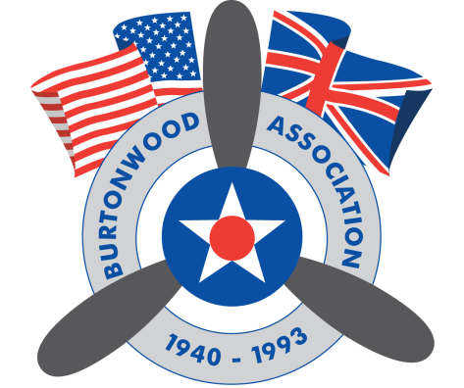
RAF BURTONWOOD ASSOCIATION
RAF BURTONWOOD HERITAGE CENTRE, GULLIVER’S WORLD
OLD HALL, WARRINGTON, WA5 9YZ

RAF BURTONWOOOD NOSTALGIC WEEKEND
15th AND 16th SEPTEMBER 2018

EXHIBITOR BOOKING FORM
EXHIBITOR DETAILS

NAME:

ADDRESS:

MOBILE:

EMAIL:

NUMBER ATTENDING:

NAME OF GROUP(This will ensure your group is located together where possible):

VEHICLE MODEL:

SPACE REQUIRED Sq Mtrs):

TYPE OF EXHIBITION/DISPLAY:

DAYS EXHIBITING (please circle): SAT SUN FULL WEEKEND

The above details are required in full to enable your booking confirmation and passes to be issued. Passes must be presented upon your arrival. They will be posted to you on confirmation of your booking.

FINAL BOOKING DATE: 1st SEPTEMBER 2018

EVENT DETAILS

Free Parking

Camping/Caravanning space available adjacent to the display area. Pitches are £10.00 per night

Stand pipe and toilets available

Arrival date/time: From 14:00 on Friday 14th September 2018.

Please note the use of generators is not permitted.

Exhibits/Displays to be in place by 09:00 on the morning of both 15th and 16th September.

For further details contact John on 07890135461. Email; john.cotterill@rafburtonwood.co.uk

On the Saturday evening of our event there will be a Nostalgic Dance held on-site. Concession tickets are available to exhibitors at £6.00 per person.

Anyone wishing to take advantage of the on-site accommodation at Gulliver’s Hotel, please visit www.gullivershotel.co.uk or call 01925 230088, for further information. Use of the promotional code BWD01 which will qualify you for a discounted hotel rate.

