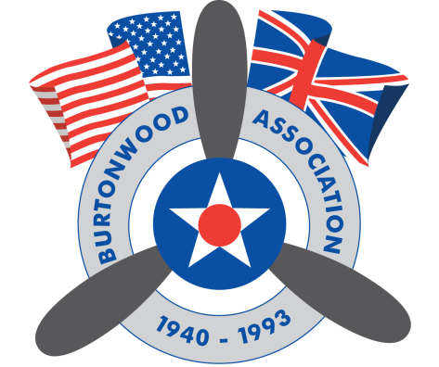
RAF BURTONWOOD ASSOCIATION
RAF BURTONWOOD HERITAGE CENTRE, GULLIVER’S WORLD
OLD HALL, WARRINGTON, WA5 9YZ

RAF BURTONWOOOD NOSTALGIC WEEKEND
9th AND 10th SEPTEMBER 2017

EXHIBITOR BOOKING FORM
EXHIBITOR DETAILS

NAME:

ADDRESS:

MOBILE:

EMAIL:

NUMBER ATTENDING:

NAME OF GROUP(This will ensure your group is located together):

VEHICLE REGESTRATION No:

SPACE REQUIRED:

TYPE OF EXHIBITION/DISPLAY:

DAYS EXHIBITING (please circle): SAT SUN FULL WEEKEND

The above details are required in full to enable your booking confirmation and passes to be issued. Passes are non-transferrable and must be presented upon your arrival. They will be posted to on confirmation of your booking.

FINAL BOOKING DATE: 1st SEPTEMBER 2016

EVENT DETAILS

Free Parking

Camping/Caravanning space available adjacent to the display area.

Stand pipe and toilets available

Arrival date/time: From 14:00 on Friday 8th September 2017.

Please note the use of generators is not permitted.

Exhibits/Displays to be in place by 09:00 on the morning of both days.

For further details contact John on 07890135461. Email; john.cotterill@rafburtonwood.co.uk

On the Saturday evening of our event there will be a Nostalgic Dance held on-site. Concession tickets are available to exhibitors at £6.00 per person.

Anyone wishing to take advantage of the on-site accommodation at Gulliver’s Hotel, please visit www.gullivershotel.co.uk or call 01925 230088, for further information. Use of the promotional code BWD01 will qualify you for a discounted hotel rate.

